Industry | Repair and protection  Photograph of the project:  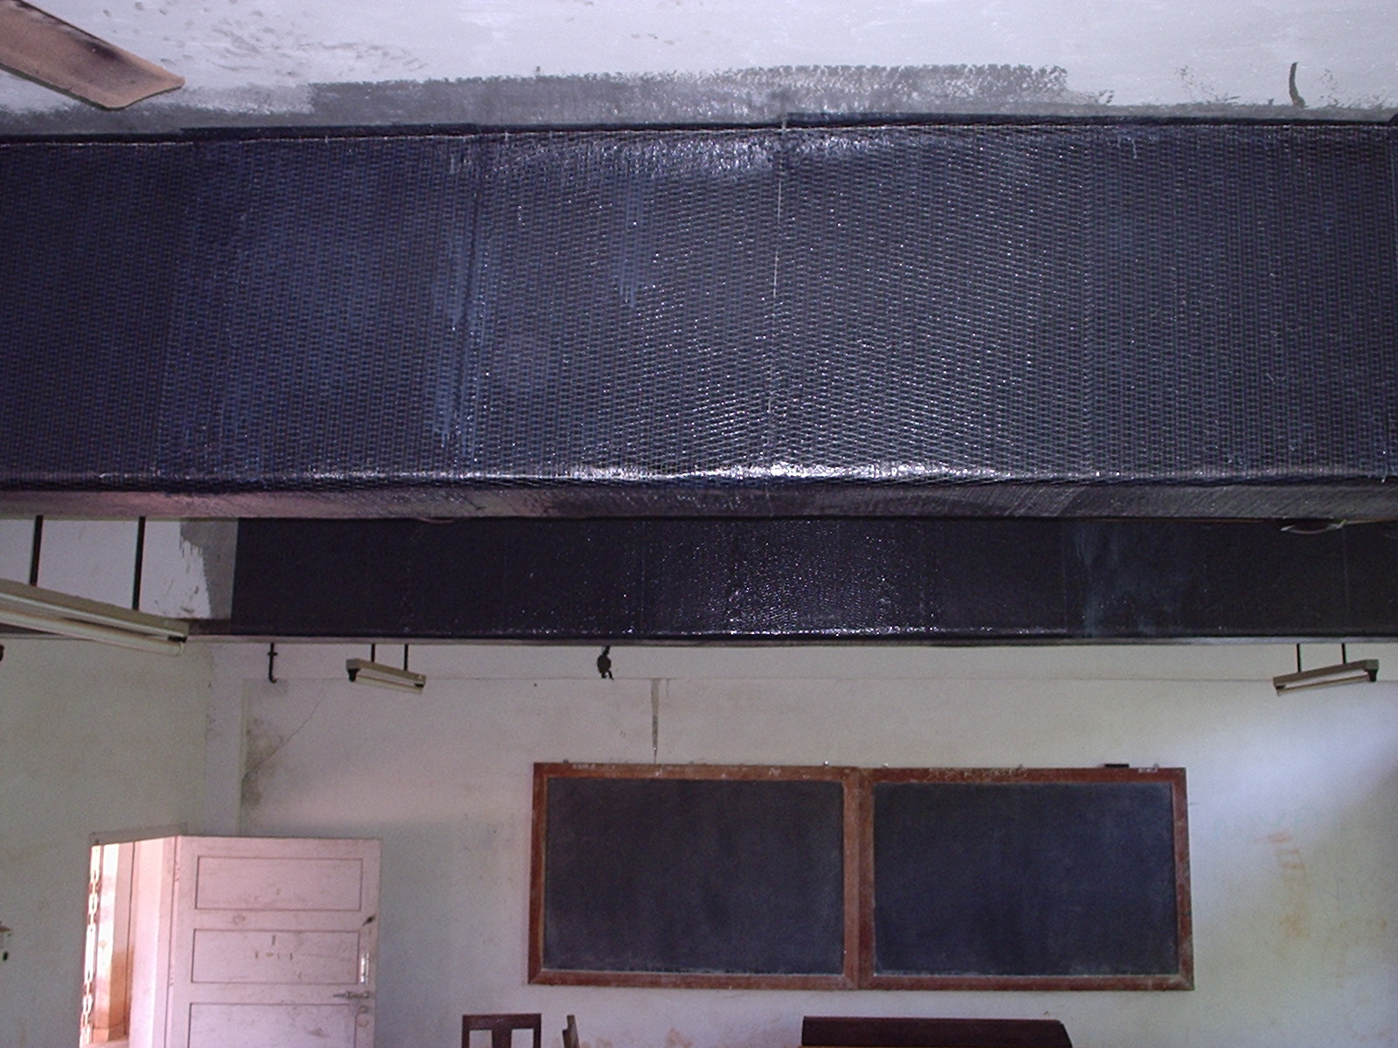
Project | Cochin University of Science and technology ( CUSAT)
Location | Cochin
Completion date | January 2006
Consultant | FEDO
Architect
Contractor | Castle sales and services
Products | Nitowrap CF , Conbextra EP 10
Project details & Customer requirement
The customers CUSAT ‘s requirement was to strengthen the existing beams of their engineering class rooms so as to give clearance to construct upper floors. The flexural and shear strength of their existing beams were insufficient to take further loads hence the requirement. Along with the consultants FEDO we proposed epoxy grouting of cracks carbon fibre wrapping which was approved and the work was carried out in a successful manner .

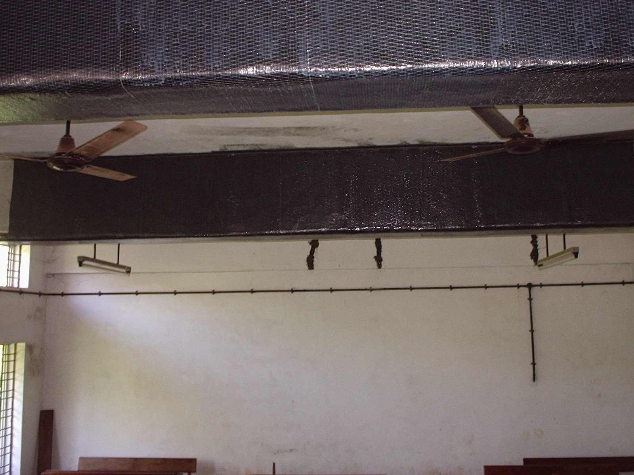

Execution
